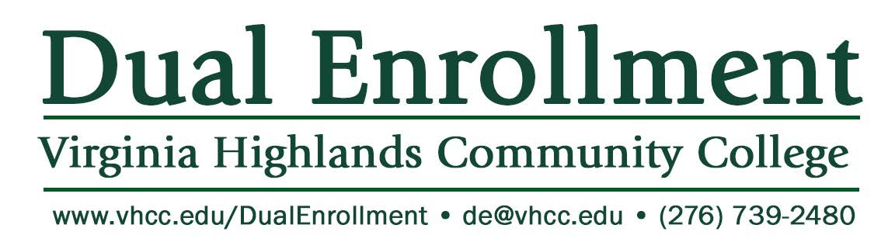
Participation Form Parent/Guardian must sign! Please return to your high school counselor.

HIGH SCHOOL:

NAME: (Print clearly)
First (REAL) Last

EMPL ID (Print clearly)

Courses for Fall 2023

Courses for Spring 2024

My signature below confirms that I am the parent/guardian of the above high school student and that he/she has my consent to enroll in VHCC Dual Enrollment course(s) listed during the semester indicated. Please note that enrollment is contingent upon successful completion of placement testing.

Signature:
Parent/Guardian Date

I understand I am enrolling in the above listed college-level dual enrollment course(s).

Signature:
Student Date

I give the student listed above permission to enroll in these course(s).

Signature:
Principal Date

(Return to your high school counselor)

Dual Enrollment Checklist

Virginia Highlands Community College is proud to partner with public schools throughout the service region to provide the Dual Enrollment Program, which allows qualified high school juniors and seniors a chance to jump start their college education. Please use the following checklist to ensure all steps have been completed.

- Meet with your high school counselor. All students interested in participating in dual enrollment classes offered by VHCC should begin by discussing the program requirements and options available with their school counselor.
- Complete the VHCC Admissions Application at www.vhcc.edu/apply In order to complete the application, you will be required to create a username and password. All
applicants will be assigned an official college identification number (EMPLID). Please write this number down for future use. If you need help with the application process, please contact the VHCC Admissions Office at (276) 739-2414.
- Complete the Dual Enrollment Participation Form. The form is included in this packet and is available online at www.vhcc.edu/dual. Students must list the courses they plan to take during the fall and spring semesters. Please be sure to sign the form and also have it signed by a parent/guardian and your high school principal. Students must complete and return this form in order to participate in the Dual Enrollment Program
- Prepare for the Placement Test (unless acceptable scores have been received on the ACT, SAT or PSAT). All students must take a Placement Test to determine eligibility for dual enrollment courses. Information about the Placement Test and a study guide is available online at www.vhcc.edu/placement or by contacting your high school Career Coach.
- Review the Dual Enrollment Handbook. The handbook is available online at www.vhcc.edu/dual and provides important information to assist you while enrolled in Dual Enrollment courses.
- Pay tuition. Please consult your high school counselor for tuition rates and the payment process.
- Complete the Dual Enrollment Scholars Program Application. Please note: Only students who plan to pursue a Uniform Certificate of General Studies or General Studies Degree while in high school should complete this form.
- Review information about The National Society of Leadership and Success. VHCC Students who meet eligibility requirements are invited to participate in this nationally recognized leadership program. Please review the enclosed information and contact the VHCC Student Services at (276) 739-2438 for additional information.

Dual Enrollment Scholars Program Application

Name: School Year:

High School:

I plan to earn the following (check one):

_ _ Uniform Certificate of General Studies (31-33 College Credits)
___

_ _ General Studies Degree (63 College Credits)
___

Recommendation of Counselor/Principal:
Signature

I intend to meet the requirements to earn the certificate/degree while I am a high school dual enrollment student at VHCC. I understand I will be required to follow all applicable VHCC policies and procedures while enrolled at VHCC.

Student Signature

My signature below authorizes my daughter/son to participate in the Dual Enrollment Scholars Program.

Parent Signature

Did you know that the VHCC Dual Enrollment Scholars Program provides opportunities for Dual Enrollment students to earn a General Education Certificate (33 college credits) at a cost that is about 5 percent of the usual tuition rate? For additional information, please go to www.vhcc.edu/dual or call (276) 739-2480.
Tuition does not include the cost of text books.

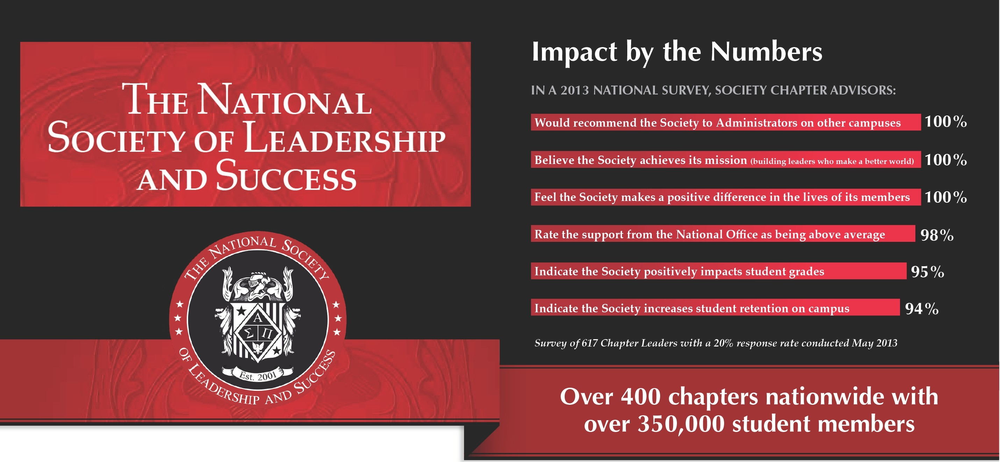

"The induction ceremon y is what reall y sold [NSLS] to me. Because, at that
moment, you get the

Why do Students Join the Society?

Improves GPA, communication skills and

Member Benefits
Beyond improved self-confidence and leadership skills members receive:

testimoni es of the students talking about how the Society has changed
their lives - it reall y touches you."
Anthony Surratt
Associate Dir ec to r, O ffice of U ndergraduate Ad missio ns

self-confidence
- Provides opportunity to apply and have access to scholarships and awards
- Increases the likelihood of securing the job of their choice
- Provides experience facilitating and
  - Access to online job bank
  - Over $125K in awards and scholarships
  - Personalized letters of recommendation
  - Leadership Certification
  - Network locally and nationally
  - Ability to wear honor cords and stole
  - Speaker Broadcast archive
  - Individual success coaching
  - Lifetime membership

New Je rsey City University

influencing peer groups
For more information about joining the VHCC chapter, please contact the VHCC Student Success Center at (276) 739-2438

What Sets the Society Apart?
The Society provides a step-by-step program for members to build their leadership skills. In order to achieve induction into the Society, they must attend their Orientation, the Leadership Training Day, 3 Success Networking Team meetings and
3 Speaker Broadcasts.
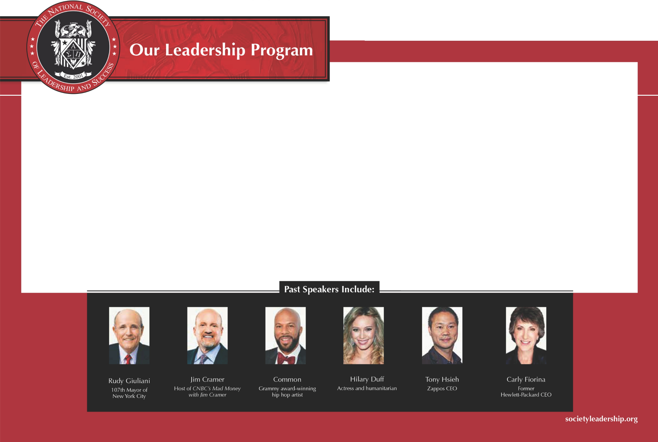
For more information about joining the VHCC chapter, please contact the VHCC Student Success Center at (276) 739-2438

The Society program delivers solutions to current issues faced on campuses today.

    - Enhances student engagement
    - Increases graduation rates
    - Saves hours of programming logistics and preparation
    - Offers quality programming on a limited budget
    - Creates opportunity for student recognition beyond grade point average

Orientation
Leadership Interactive Success
Training Day Speaker Broadcasts Networking Teams Induction Ceremony

-----0·-----------..0.
·-----------..0.
·-----------·0...----------..0.
·-----

This is the first event on campus for new members. Students learn the steps of the leadership development program and the schedule of events for the semester.
Student members attend an interactive video training session where they identify goals and overcome obstacles. This interactive and introspec­
tive seminar helps members identify their true passions and strengths while creating action steps to achieve
their goals.
Live streamed events with leaders, celebrities and best-selling authors are
scheduled 6 times per year. Topics include leadership, identifying goals, facing challenges, personal growth and successfully transition­ ing from college to career. Students interact with the speakers via Twitter and Facebook during each broadcast.
Students are assigned to small groups and meet bi-weekly to set goals for future success. Members
hold each other accountable using a highly specialized formula proven to produce results. After each meeting, students submit a reflective journal entry online, provid­ ing advisors the opportunity to coach and mentor in a for­ mat which actively engages students.
This is the final step towards induction. Most campuses hold a formal induction ceremony which can be shared with family and friends. At this ceremony, students are presented
with their Certificate of Leadership Training honor­ ing their achievement and lifetime membership in
the Society.

